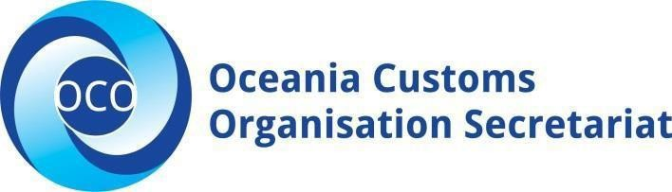

JOB DESCRIPTION – OCO SECRETARIAT

JOB TITLE: | IPR Project  Coordinator | AREA: | Operations Division
REPORTS TO: | Operations Manager | LAST REVIEWED: | 01/02/23
EMPLOYMENT TERM: | Maximum 3 Years only, and subject to project funding. | SALARY BAND: | $FJD35,000

PURPOSE:
The IPR Project Coordinator will coordinate technical assistance and training programs in the field of intellectual property rights border enforcement. The role will work closely with USPTO coordinators, delivering the activities in selected OCO members to ensure the intellectual property rights (IPR) in the Customs legislations are in line with international best practice. This role will build capacity and ensure a sound legal framework is in place for Customs administrations to be able to carry out compliance and enforcement work in IPR.

The IPR Project Coordinator will be responsible for the following key tasks:

KEY RELATIONSHIPS:
External | Internal
External  - USPTO (Team Leaders and Specialists)  - Project Consultants  - Auditors  - Other Relevant Stakeholders | - Head of Secretariat  - Operations Manager  - Steering Committee  - OCO FCSM

KEY ACCOUNTABILITIES:
Responsibilities | Expected Outcomes
1 Project Coordination and Facilitation  - Coordinate progress of member’s Customs IPR legislation status.  - Organize and coordinate training and assemble IPR Legislation Training Material.  - Organize training material for the model legislative development to be used by participating member countries.  - Coordinate with national administrations on their IPR legislative drafting needs.  - Organize webinars and training in consultation with USPTO, OCO and member countries.  - Ensure monitoring and evaluation are conducted for IPR related projects. | - Ensure OCO member awareness of relevant model IPR legislation to be included in their Customs Legislation.  - Ensure that OCO Members go through the process of incorporating relevant IPR Clauses in their Customs Legislation.  - Organize training of appropriate members’ personnel in technical IPR Legislative Drafting.  - Improve IPR public awareness and visibility  - Create a framework of action regarding Customs IPR legislative work in the Pacific region.  - Ensure timely acquittals and narrative are submitted to the partner for project reconciliation and further funding.

Responsibilities | Expected Outcomes
2. Other
- Undertake other relevant activities as deemed necessary by the Operations Manager of the OCO Secretariat Office.

EMPLOYEE SPECIFICATION:
Mandatory | Desirable
Formal Qualifications
- Undergraduate degree in social sciences. | - Relevant post graduate qualifications
Knowledge and Experience
- Excellent computer skills (MS Access, Excel, Word and power point).  - Experience in project coordination, monitoring and evaluation.  - Experience in organising and coordinating training.  - Proven ability to meet deadlines, and flexible approach to problem solving with demonstrated experience and skill in priority setting. | - Demonstrated experience working with regional funded projects;  - Previous working experience in small Pacific island countries

Key Skills/Attributes Key Behaviors
Proficient Level  - Project Coordination and Facilitation  - Project planning, monitoring and reporting  Advanced Level  - Proven ability to understand complex legal concepts, conduct thorough research, and devise solutions to potential project challenges and risks.  Working Knowledge Level  - Skills in negotiation and conflict resolution are essential for managing relationships with different parties and ensuring project alignment.  - A solid, practical understanding of intellectual property rights and relevant legal frameworks.  - The ability to build and maintain positive relationships with regional partners and international organisations to foster collaboration.  - Record keeping and document management | - Commitment and Personal Accountability  - Professional and Technical Expertise  - Ability to work within small teams or work independently  - Customer Focus approach  - Effective Communication skills  - Relationship building with key stakeholders

KEY RESULTS AREA:

The role of the IPR Project Coordinator encompasses the following major functions or key results area:

- Project Coordination and Facilitation

AUTHORITIES:
Delegations/Contractual - Commensurate with the OCO Administration Policy, the level of authority to enter into contracts or negotiations on behalf of the organization.

Financial - Delegations in line with the OCO Administration Policy and Finance Policies and Procedures.

CHANGES TO THE JOB DESCRIPTION

Throughout the course of this project, it may be necessary to consider changes in the job description in response to the changing nature of the work environment -including technological advancements or statutory changes. Such change may be initiated as necessary by the OCO. This Job Description will be reviewed as part of the preparation for performance planning for the annual performance cycle.

Approved:

Head of Secretariat Date

Employee Date

