POSITION DESCRIPTION
JOB TITLE:
Executive Assistant
AREA:
Finance & Corporate Services
REPORTS TO:
Head of Secretariat
3 Year Contract
LAST REVIEWED:
SALARY BAND:
November 2024
EMPLOYMENT TERM:
Commencing FJD$ 40,819
PURPOSE:
To provide high level administrative and communication support to the Executive and management staff
of OCO and ensure that Corporate Service deliverables effectively and efficiently meet deadlines and
expectations.
KEY RELATIONSHIPS:
External
Internal
•
•
•
•
•
Steering Committee
OCO Members
Regional Stakeholders
Development Partners
Donors
•
•
•
•
Head of Secretariat
Finance & Corporate Services Manager
Operations Manager
Other staff
KEY ACCOUNTABILITIES:
Responsibility
Expected Outcomes
Information Management Support
•
The information produced is complete,
•
Produce information by transcribing,
formatting, inputting, editing, researching,
retrieving, copying and transmitting text,
data and graphics
accurate, professionally and timely presented
Confidential and sensitive information is kept
secure and is not disclosed to unauthorised
parties
•
•
•
•
•
Prepare meeting agendas, take minutes of
meetings and circulate meeting papers
Devise and consistently maintain the
physical and electronic filing system
Respond to emails and other
correspondences as directed
Provide brief updates/reports on assigned
work, as required
•
•
Relevant old files and documents are digitized
Minutes of the meetings accurately record
discussions and decisions made
The filing system is secure and confidential
information is protected by restricted /
authorised access
Both physical and electronic files are
systematically referenced, maintained and
user friendly
•
•
•
•
The responses to emails/correspondence are
sent in an accurate and timely fashion
Reports/briefs on assigned works/tasks are
submitted on time, accurate and succinctly
written
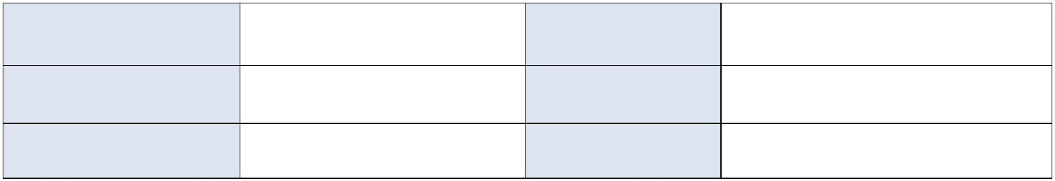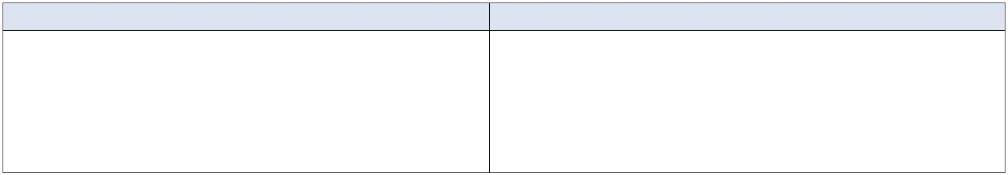

Administrative Support
•
•
Compliance of good office practice is
maintained and/or improved
Assistance is provided to the HR & Logistics
Officer as needed to ensure the smooth
running of the office.
•
Assist in the administrative and logistics as
and when required.
•
Office management duties including
procurement of stationery, office supplies
and staff amenities, and preparation of
corresponding payment vouchers and
purchase requisitions
•
Well run and appropriately supplied office
Executive Time Management Support
•
•
•
The Executive staff is systematic and diligent
in responding to responsibilities
•
Maintain / assist with the Executive staff
appointment schedules that include
meetings, conferences, teleconferences
and travels
The Executive staff is consistently capable of
meeting deadlines on key responsibilities
Assist the accountant when asked to process
claims for reimbursement of official
expenditures and allowance entitlements
resulting in the reimbursements/ refunds/
allowances being paid to staff on time
Assist HoS to ensure all preparations for
Steering Committees and Annual OCO
Conference from logistics to Steering
Committee and Conference Papers and
records of summaries meeting minutes and
etc…, are all ready before the respective
meetings take place.
•
•
Assist with - correspondence, draft letters
and documents, collect and analyse
information and initiate communications
Assist HoS with ensuring all preparations
for Steering Committees quarterly
Meetings and Annual OCO Conferences
from the strategic and logistics aspects
(including all papers) are completed
within schedule. Note : Except for
calculations of members and staff
perdiems that will still be prepared by
HRLO.
•
Public Relations – Director of First Impressions
•
•
•
The reputation and image of the OCO is
protected and intact at all times
OCO is perceived to be a warm, friendly and
welcoming organisation
The network and communication channel with
OCO stakeholders is constantly revisited in the
interest of all parties
The coordination of arrangements for visiting
and departing OCO guests and staff is efficient
and effectively managed
•
•
•
Greet and treat visitors with respect and
courtesy in person or over the phone at all
times
Liaise with OCO staff, stakeholders,
suppliers and other external organisations
as and when required.
Arrange/facilitate travel, accommodation,
allowance entitlements and other benefits
for OCO staff and visitors
•
•
Other
Additional duties/tasks required are
performed conscientiously and in a timely
manner
•
Undertake all other duties that may be
assigned by the Head of Secretariat or
management staff
•
Assist running errands and/or driving, as
needed
Health and Safety
•
•
•
•
OCO health and safety policies and
procedures are understood and followed
Identified hazards are efficiently and
effectively addressed
Participation in health and safety audits of
work is proactive
•
Active contribution to the maintenance of
a safe and healthy work environment
An understanding of emergency and
evacuation procedures is demonstrated
ORGANISATIONAL CONTEXT:
Page 2 of 5


Head of Secretariat
Management Team
This role
Tier 1
Tier 2
Tier 4
Page 3 of 5


KEY RESULT AREAS:
The role of Executive Assistant encompasses the following major functions or key result areas:
•
•
•
•
•
•
Information Management Support
Administrative and Communication Support
Executive Time Management Support
Public Relations – Director of First Impressions
Other
Health and Safety
This is a position of trust and it is likely you will become aware of sensitive, confidential and private
information that must not be disclosed to others – either internally or externally. If material or information
is discovered which is inappropriate and contravenes the OCO policies, then this should be escalated to
your Supervisor immediately.
ROLE COMPLEXITY:
•
•
•
Agility required to meet the demands of more than one manager
Flexibility of hours to meet deadlines and support the Executive as needed
Necessity to think outside the box and find solutions
AUTHORITIES:
Delegations/Contractual -
Initial investigation only – the level of authority to enter into contracts or
negotiations on behalf of the organisation
Staff -
n/a
Financial -
There is no financial authority - All financial authority belongs to the
Finance & Corporate Services Manager
Page 4 of 5

PERSON SPECIFICATION:
Mandatory
Desirable
Formal Qualifications
•
A relevant tertiary qualification (minimum
•
An industry-recognised qualification in
diploma) in office administration or related
discipline
business administration
Knowledge and Experience
•
At least five years of experience working
as a Personal or Executive Assistant to a
CEO or equivalent
Knowledge of standard office
administrative practices and procedures
•
•
Experience in a regional/international
organisation
Valid Driver’s license
•
Skills
•
Exhibit excellent communication skills,
both written and verbal in English
Proficient computer skills computer
literacy including at least intermediate
level of skill in MS Word, Excel and
PowerPoint
•
•
•
Proficient in Minute-taking
Excellent self-management skills (both
organisation and time-management)
Ability to work well within a team
Exceptional information gathering and
monitoring skills
•
•
•
•
•
Excellent interpersonal skills
Stress management skills
Ability to maintain a high level of accuracy
and confidentiality concerning classified
documents, financials and handling staff
files
Attributes
•
•
•
•
•
Positive ‘can do’ attitude
Professional appearance
A team player
Trustworthy with strong moral ethics
Willingness to work additional hours when
necessary (flexible and agile)
•
Ability to work laterally and identify
innovative solutions
•
•
Common sense, practical and result-
focused
approach
and
achievement
orientation
Customer Service Commitment Confident
and able to handle conflict situations and
negotiations at various levels
•
•
Empathetic to all levels and cultures
present in the organisation
Cultural and gender sensitivity
Page 5 of 5


CHANGE TO JOB DESCRIPTION
From time to time it may be necessary to consider changes in the job description in response
to the changing nature of the work environment - including technological requirements or
statutory changes. Such change may be initiated as necessary by OCO. This Job Description may
also be reviewed as part of the preparation for performance planning for the annual
performance cycle.
Approved:
Head of Secretariat
Date
Date
Employee
Page 6 of 5

